Bux180 Release Notes for Production Deployment – 12/02/2013

Contents

Ticket 27: Local Directory 4

Add local directory: 4

Preview 4

Draft 4

Publish 4

Cancel 4

View local directory 6

View 6

Edit 6

Delete: 6

Table creations: 7

State table 7

Partner Property table 11

Ticket : 32 - design change internal member page after sign. 14

Design changes: 14

Ticket : 37- Change wording in hot products – changing wordings in the hot products from admin app. 14

Design changes: 14

http://pmt.cozelixindia.com/index.php/ticketsComments?tickets_id=37&projects_id=9 14

Ticket : 38- Dynamically display the Company Name in the banner. 14

Design changes: 14

http://pmt.cozelixindia.com/index.php/ticketsComments?tickets_id=38&projects_id=9 14

Technical Specifications: 14

Ticket : 39- Sticky notes error. 14

Design changes: 14

Technical Specifications: 15

Ticket : 40- change wording in email ( "send us a quick email at associates.bux180.com" It should be associates@bux180.com). 15

Design changes: 15

Ticket : 42- Local directory change. 15

Design changes: 15

Technical Specifications: 15

Functional Specifications: 15

Ticket : 45- Hot products blue box wording – hot products write and change this blue wording from the admin site. 16

Design changes: 16

http://pmt.cozelixindia.com/index.php/ticketsComments?tickets_id=45&projects_id=9 16

Ticket : 47- copy & few adjustments for member site(document revisions 11.28). 16

Design changes: 16

Ticket : 49- blue box in associate header(Please extend the bottom of the blue box. This is incorrect ONLY on the internal home page). 16

Design changes: 16

# Ticket 27: Local Directory

In Associate App we newly add Local Directory here associate can add local directory it will be displayed in local directory of that partner’s member app.

With this local directory page Associate can manage their local directory.

It contains two sub-menus:

* Add local directory
* View local directory

## Add local directory:

In this page associate can add their local directory.

If an associate was loan officer they can create home improvement/real estate local directory.

If an associate was real estate they can create home improvement/ loan officer local directory.

Based local directory type it will be display in the member page options.

If local directory type was loan officer associate can give NMLS Code in local directory.

It had four option

### Preview

After filling all the fields in the local directory page associate can see the preview of that local directory.

It was helpful to associate when add local directory if any changes need it can their itself.

### Draft

If associate click this button that local directory will be published in member local directory application.

### Publish

If associate click this button that local directory will not published in member local directory application, it will considered as draft local directory.

### Cancel

If associate click cancel button it will goes to local directroy view page.

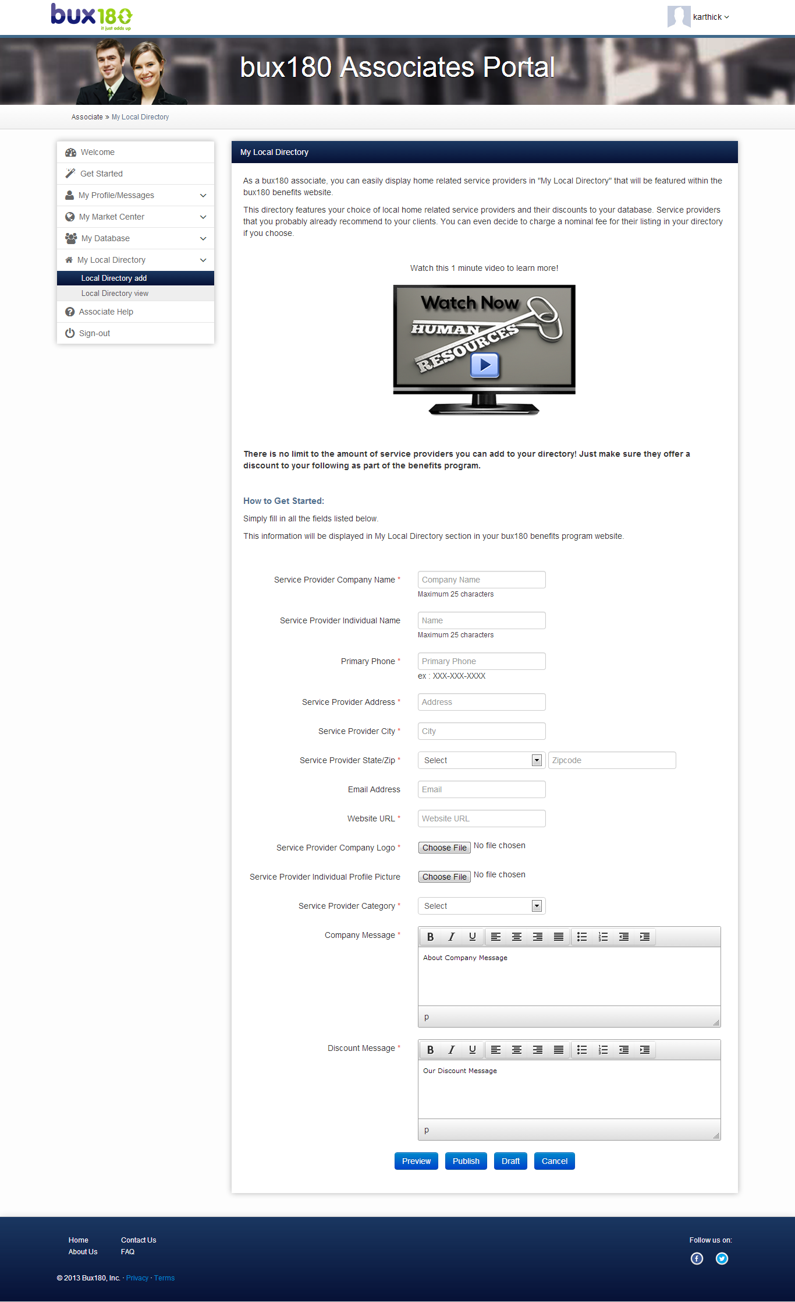

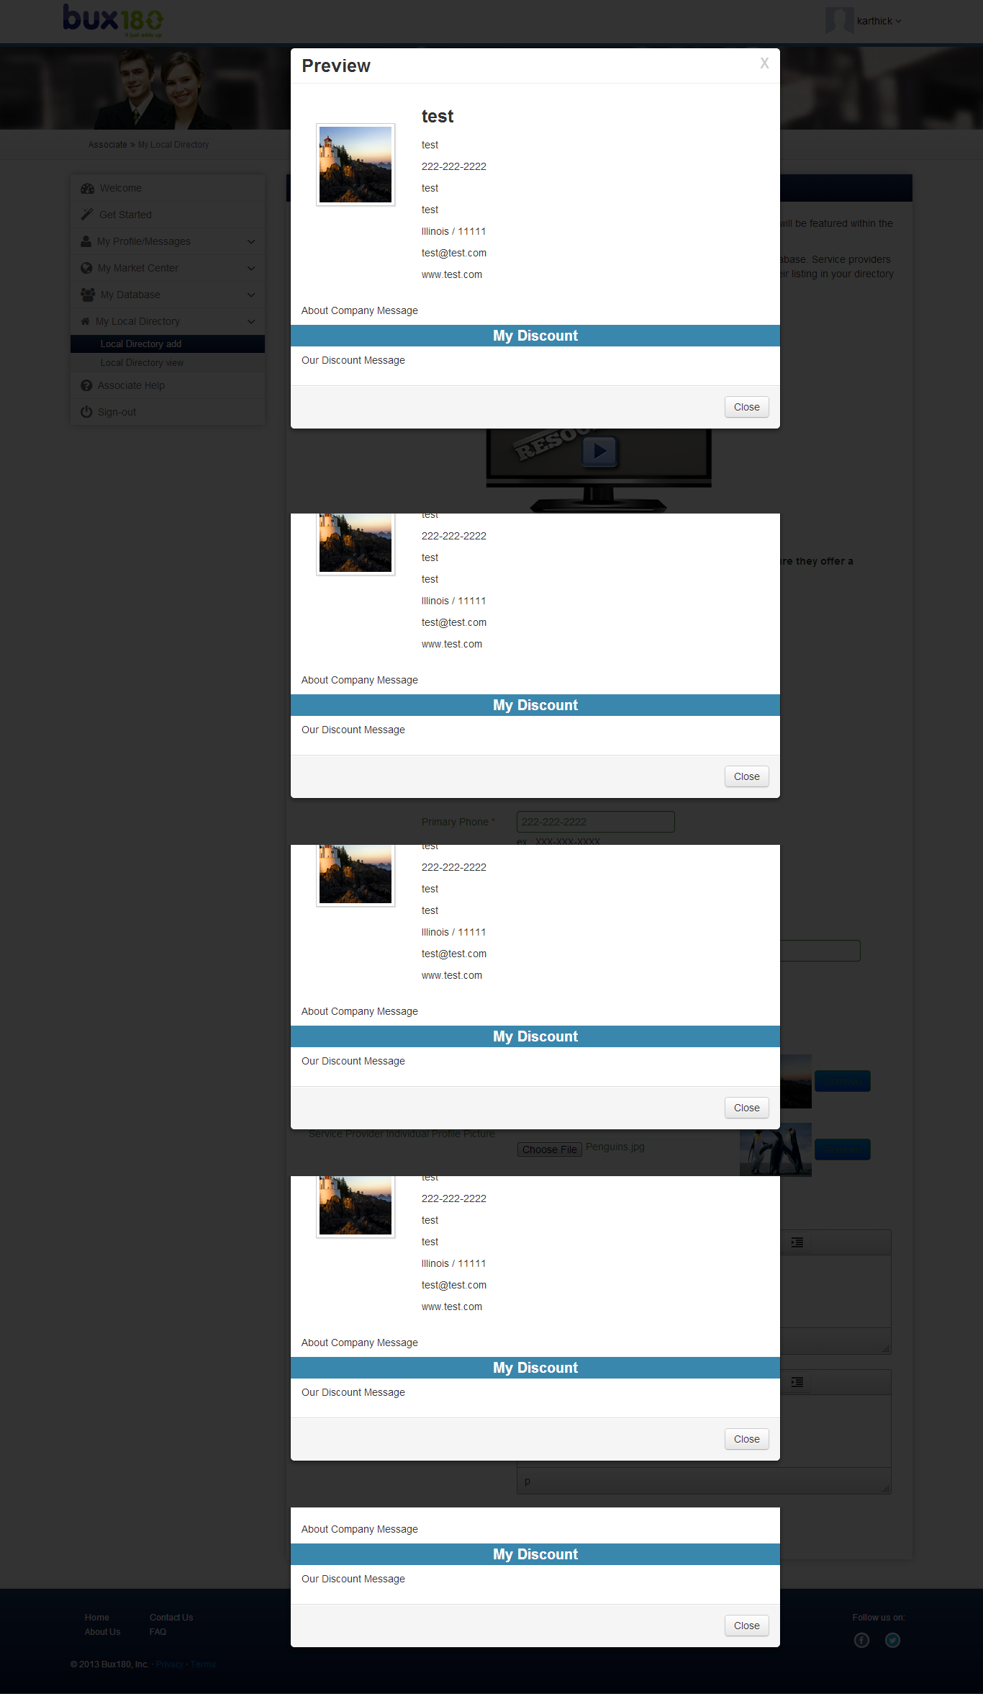

## View local directory

In view local directory associate can view their local directory.

It had two options

* view
* Delete

### View

Here associate can view local directory as preview if they want to edit, they can edit it using edit button in this page.

### Edit

In edit page associate can edit their local directory, this edit page is similar local directory add page.

### Delete:

Here associate can delete unwanted local directory.

# Table creations:

## State table

-- phpMyAdmin SQL Dump

-- version 3.5.5

-- http://www.phpmyadmin.net

--

-- Host: localhost

-- Generation Time: Nov 26, 2013 at 06:03 AM

-- Server version: 5.1.69

-- PHP Version: 5.3.3

SET SQL_MODE="NO_AUTO_VALUE_ON_ZERO";

SET time_zone = "+00:00";

/*!40101 SET @OLD_CHARACTER_SET_CLIENT=@@CHARACTER_SET_CLIENT */;

/*!40101 SET @OLD_CHARACTER_SET_RESULTS=@@CHARACTER_SET_RESULTS */;

/*!40101 SET @OLD_COLLATION_CONNECTION=@@COLLATION_CONNECTION */;

/*!40101 SET NAMES utf8 */;

--

-- Database: `bux180`

--

-- --------------------------------------------------------

--

-- Table structure for table `state`

--

CREATE TABLE IF NOT EXISTS `state` (

`ID` int(16) unsigned NOT NULL AUTO_INCREMENT,

`NAME` varchar(50) DEFAULT NULL,

`DESCRIPTION` varchar(200) DEFAULT NULL,

`status_id` int(16) unsigned NOT NULL,

`created` datetime NOT NULL,

`modified` datetime NOT NULL,

PRIMARY KEY (`ID`),

KEY `FK_state1` (`status_id`)

) ENGINE=InnoDB DEFAULT CHARSET=latin1 AUTO_INCREMENT=57 ;

--

-- Dumping data for table `state`

--

INSERT INTO `state` (`ID`, `NAME`, `DESCRIPTION`, `status_id`, `created`, `modified`) VALUES

(1, 'American Samoa', 'American Samoa', 1, '0000-00-00 00:00:00', '0000-00-00 00:00:00'),

(2, 'Alabama', 'Alabama', 1, '2013-11-21 11:57:49', '0000-00-00 00:00:00'),

(3, 'Alaska', 'Alaska', 1, '2013-11-21 11:57:49', '0000-00-00 00:00:00'),

(4, 'Arizona', 'Arizona', 1, '2013-11-21 11:57:49', '0000-00-00 00:00:00'),

(5, 'Arkansas', 'Arkansas', 1, '2013-11-21 11:57:49', '0000-00-00 00:00:00'),

(6, 'California', 'California', 1, '2013-11-21 11:57:49', '0000-00-00 00:00:00'),

(7, 'Colorado', 'Colorado', 1, '2013-11-21 11:57:49', '0000-00-00 00:00:00'),

(8, 'Connecticut', 'Connecticut', 1, '2013-11-21 11:57:49', '0000-00-00 00:00:00'),

(9, 'Delaware', 'Delaware', 1, '2013-11-21 11:57:49', '0000-00-00 00:00:00'),

(10, 'District of Columbia', 'District of Columbia', 1, '2013-11-21 11:57:49', '0000-00-00 00:00:00'),

(11, 'Florida', 'Florida', 1, '2013-11-21 11:57:49', '0000-00-00 00:00:00'),

(12, 'Georgia', 'Georgia', 1, '2013-11-21 11:57:49', '0000-00-00 00:00:00'),

(13, 'Guam', 'Guam', 1, '2013-11-21 11:57:49', '0000-00-00 00:00:00'),

(14, 'Hawaii', 'Hawaii', 1, '2013-11-21 11:57:49', '0000-00-00 00:00:00'),

(15, 'Idaho', 'Idaho', 1, '2013-11-21 11:57:49', '0000-00-00 00:00:00'),

(16, 'Illinois', 'Illinois', 1, '2013-11-21 11:57:49', '0000-00-00 00:00:00'),

(17, 'Indiana', 'Indiana', 1, '2013-11-21 11:57:49', '0000-00-00 00:00:00'),

(18, 'Iowa', 'Iowa', 1, '2013-11-21 11:57:49', '0000-00-00 00:00:00'),

(19, 'Kansas', 'Kansas', 1, '2013-11-21 11:57:49', '0000-00-00 00:00:00'),

(20, 'Kentucky', 'Kentucky', 1, '2013-11-21 11:57:49', '0000-00-00 00:00:00'),

(21, 'Louisiana', 'Louisiana', 1, '2013-11-21 11:57:49', '0000-00-00 00:00:00'),

(22, 'Maine', 'Maine', 1, '2013-11-21 11:57:49', '0000-00-00 00:00:00'),

(23, 'Maryland', 'Maryland', 1, '2013-11-21 11:57:49', '0000-00-00 00:00:00'),

(24, 'Massachusetts', 'Massachusetts', 1, '2013-11-21 11:57:49', '0000-00-00 00:00:00'),

(25, 'Michigan', 'Michigan', 1, '2013-11-21 11:57:49', '0000-00-00 00:00:00'),

(26, 'Minnesota', 'Minnesota', 1, '2013-11-21 11:57:49', '0000-00-00 00:00:00'),

(27, 'Mississippi', 'Mississippi', 1, '2013-11-21 11:57:49', '0000-00-00 00:00:00'),

(28, 'Missouri', 'Missouri', 1, '2013-11-21 11:57:49', '0000-00-00 00:00:00'),

(29, 'Montana', 'Montana', 1, '2013-11-21 11:57:49', '0000-00-00 00:00:00'),

(30, 'Nebraska', 'Nebraska', 1, '2013-11-21 11:57:49', '0000-00-00 00:00:00'),

(31, 'Nevada', 'Nevada', 1, '2013-11-21 11:57:49', '0000-00-00 00:00:00'),

(32, 'New Hampshire', 'New Hampshire', 1, '2013-11-21 11:57:49', '0000-00-00 00:00:00'),

(33, 'New Jersey', 'New Jersey', 1, '2013-11-21 11:57:49', '0000-00-00 00:00:00'),

(34, 'New Mexico', 'New Mexico', 1, '2013-11-21 11:57:49', '0000-00-00 00:00:00'),

(35, 'New York', 'New York', 1, '2013-11-21 11:57:49', '0000-00-00 00:00:00'),

(36, 'North Carolina', 'North Carolina', 1, '2013-11-21 11:57:49', '0000-00-00 00:00:00'),

(37, 'North Dakota', 'North Dakota', 1, '2013-11-21 11:57:49', '0000-00-00 00:00:00'),

(38, 'Northern Marianas Islands', 'Northern Marianas Islands', 1, '2013-11-21 11:57:49', '0000-00-00 00:00:00'),

(39, 'Ohio', 'Ohio', 1, '2013-11-21 11:57:49', '0000-00-00 00:00:00'),

(40, 'Oklahoma', 'Oklahoma', 1, '2013-11-21 11:57:49', '0000-00-00 00:00:00'),

(41, 'Oregon', 'Oregon', 1, '2013-11-21 11:57:49', '0000-00-00 00:00:00'),

(42, 'Pennsylvania', 'Pennsylvania', 1, '2013-11-21 11:57:49', '0000-00-00 00:00:00'),

(43, 'Puerto Rico', 'Puerto Rico', 1, '2013-11-21 11:57:49', '0000-00-00 00:00:00'),

(44, 'Rhode Island', 'Rhode Island', 1, '2013-11-21 11:57:49', '0000-00-00 00:00:00'),

(45, 'South Carolina', 'South Carolina', 1, '2013-11-21 11:57:49', '0000-00-00 00:00:00'),

(46, 'South Dakota', 'South Dakota', 1, '2013-11-21 11:57:49', '0000-00-00 00:00:00'),

(47, 'Tennessee', 'Tennessee', 1, '2013-11-21 11:57:49', '0000-00-00 00:00:00'),

(48, 'Texas', 'Texas', 1, '2013-11-21 11:57:49', '0000-00-00 00:00:00'),

(49, 'Utah', 'Utah', 1, '2013-11-21 11:57:49', '0000-00-00 00:00:00'),

(50, 'Vermont', 'Vermont', 1, '2013-11-21 11:57:49', '0000-00-00 00:00:00'),

(51, 'Virginia', 'Virginia', 1, '2013-11-21 11:57:49', '0000-00-00 00:00:00'),

(52, 'Virgin Islands', 'Virgin Islands', 1, '2013-11-21 11:57:49', '0000-00-00 00:00:00'),

(53, 'Washington', 'Washington', 1, '2013-11-21 11:57:49', '0000-00-00 00:00:00'),

(54, 'West Virginia', 'West Virginia', 1, '2013-11-21 11:57:49', '0000-00-00 00:00:00'),

(55, 'Wisconsin', 'Wisconsin', 1, '2013-11-21 11:57:49', '0000-00-00 00:00:00'),

(56, 'Wyoming', 'Wyoming', 1, '2013-11-21 11:57:49', '0000-00-00 00:00:00');

--

-- Constraints for dumped tables

--

--

-- Constraints for table `state`

--

ALTER TABLE `state`

ADD CONSTRAINT `FK_state1` FOREIGN KEY (`status_id`) REFERENCES `status` (`ID`);

/*!40101 SET CHARACTER_SET_CLIENT=@OLD_CHARACTER_SET_CLIENT */;

/*!40101 SET CHARACTER_SET_RESULTS=@OLD_CHARACTER_SET_RESULTS */;

/*!40101 SET COLLATION_CONNECTION=@OLD_COLLATION_CONNECTION */;

## Partner Property table

CREATE TABLE `Partner_property` (  
 `ID` int(11) NOT NULL AUTO_INCREMENT,  
 `Partner_ID` int(16) unsigned NOT NULL,  
 `Property_Type` int(16) unsigned NOT NULL,  
 `Property_Value` varchar(20) NOT NULL,  
 `Created_date` datetime NOT NULL,  
 `Modify_date` datetime DEFAULT NULL,  
 PRIMARY KEY (`ID`),  
 KEY `FK_partner_property1` (`Property_Type`),  
 CONSTRAINT `FK_partner_property1` FOREIGN KEY (`Property_Type`) REFERENCES `partner_company_type` (`ID`)  
) ENGINE=InnoDB AUTO_INCREMENT=7 DEFAULT CHARSET=latin1

partner_local_directory table

CREATE TABLE `partner_local_directory` (  
 `ID` int(16) unsigned NOT NULL AUTO_INCREMENT,  
 `Partner_ID` int(16) unsigned NOT NULL,  
 `Company_Name` varchar(25) CHARACTER SET latin1 NOT NULL,  
 `Service_Provider_Name` varchar(25) CHARACTER SET latin1 DEFAULT NULL,  
 `Primary_Phone` varchar(12) CHARACTER SET latin1 NOT NULL,  
 `Address` varchar(150) CHARACTER SET latin1 NOT NULL,  
 `City` varchar(50) CHARACTER SET latin1 NOT NULL,  
 `State_Id` int(16) unsigned NOT NULL,  
 `Zipcode` int(5) NOT NULL,  
 `Email_Address` varchar(100) COLLATE utf8_unicode_ci DEFAULT NULL,  
 `WEBSITE_URL` varchar(100) COLLATE utf8_unicode_ci DEFAULT NULL,  
 `Company_Logo` varchar(200) CHARACTER SET latin1 NOT NULL,  
 `Profile_picture` varchar(200) CHARACTER SET latin1 DEFAULT NULL,  
 `Service_Provider_Category_Id` int(16) unsigned NOT NULL,  
 `Company_Message` text CHARACTER SET latin1,  
 `Company_Discount` text CHARACTER SET latin1,  
 `Status_id` int(16) unsigned NOT NULL,  
 `Created_date` timestamp NOT NULL DEFAULT CURRENT_TIMESTAMP ON UPDATE CURRENT_TIMESTAMP,  
 `Modify_date` timestamp NOT NULL DEFAULT '0000-00-00 00:00:00',  
 PRIMARY KEY (`ID`),  
 KEY `FK_partner_local_directory2` (`Service_Provider_Category_Id`),  
 KEY `FK_partner_local_directory3` (`Status_id`),  
 KEY `FK_partner_local_directory1` (`State_Id`),  
 CONSTRAINT `FK_partner_local_directory1` FOREIGN KEY (`State_Id`) REFERENCES `state` (`ID`),  
 CONSTRAINT `FK_partner_local_directory2` FOREIGN KEY (`Service_Provider_Category_Id`) REFERENCES `partner_company_type` (`ID`),  
 CONSTRAINT `FK_partner_local_directory3` FOREIGN KEY (`Status_id`) REFERENCES `status` (`ID`)  
) ENGINE=InnoDB AUTO_INCREMENT=25 DEFAULT CHARSET=utf8 COLLATE=utf8_unicode_ci

Partner_local_directory_property table

CREATE TABLE `Partner_local_directory_property` (  
 `ID` int(11) NOT NULL AUTO_INCREMENT,  
 `Partner_Local_Directory_Id` int(16) unsigned NOT NULL,  
 `Service_Provider_Category_Id` int(16) unsigned NOT NULL,  
 `Property_Value` varchar(20) NOT NULL,  
 `Created_date` datetime NOT NULL,  
 `Modify_date` datetime NOT NULL,  
 PRIMARY KEY (`ID`),  
 KEY `FK_Partner_local_directory_property2` (`Partner_Local_Directory_Id`),  
 KEY `FK_Partner_local_directory_property1` (`Service_Provider_Category_Id`),  
 CONSTRAINT `FK_Partner_local_directory_property1` FOREIGN KEY (`Service_Provider_Category_Id`) REFERENCES `partner_company_type` (`ID`),  
 CONSTRAINT `FK_Partner_local_directory_property2` FOREIGN KEY (`Partner_Local_Directory_Id`) REFERENCES `partner_local_directory` (`ID`)  
) ENGINE=InnoDB AUTO_INCREMENT=52 DEFAULT CHARSET=latin1

# 

# Ticket : 32 - design change internal member page after sign.

## Design changes:

To update the changes as per the document in the ticket 32. The link is given below

<http://pmt.cozelixindia.com/index.php/ticketsComments?tickets_id=32&projects_id=9>

# Ticket : 37- Change wording in hot products – changing wordings in the hot products from admin app.

## Design changes:

To update the changes as per the document in the ticket 37. The link is given below

## <http://pmt.cozelixindia.com/index.php/ticketsComments?tickets_id=37&projects_id=9>

# Ticket : 38- Dynamically display the Company Name in the banner.

## Design changes:

To update the changes as per the document in the ticket 38. The link is given below

## <http://pmt.cozelixindia.com/index.php/ticketsComments?tickets_id=38&projects_id=9>

## Technical Specifications:

When member sign into bux180 it will display Partner company name in the banner.

# Ticket : 39- Sticky notes error.

## Design changes:

To update the changes as per the document in the ticket 39. The link is given below

<http://pmt.cozelixindia.com/index.php/ticketsComments?tickets_id=39&projects_id=9>

## Technical Specifications:

When member sign into bux180 it will display member first name in the recipient field and partner’s first name, last name in sincerely field in welcome page.

# Ticket : 40- change wording in email ( "send us a quick email at associates.bux180.com" It should be [associates@bux180.com](mailto:associates@bux180.com)).

## Design changes:

To update the changes as per the document in the ticket 40. The link is given below

<http://pmt.cozelixindia.com/index.php/ticketsComments?tickets_id=40&projects_id=10>

# Ticket : 42- Local directory change.

## Design changes:

To update the changes as per the document in the ticket 42. The link is given below

<http://pmt.cozelixindia.com/index.php/ticketsComments?tickets_id=42&projects_id=9>

## Technical Specifications:

Based on the partner company type local directory in member app will display the left menu. If partner company type was real estate it will not display real estate in local directory menu.

# Functional Specifications:

It checks member’s partner company type and it displays other than that partner company type. So If partner company type was real estate it will not display real estate in local directory menu.

# Ticket : 45- Hot products blue box wording – hot products write and change this blue wording from the admin site.

## Design changes:

To update the changes as per the document in the ticket 45. The link is given below

## <http://pmt.cozelixindia.com/index.php/ticketsComments?tickets_id=45&projects_id=9>

# Ticket : 47- copy & few adjustments for member site(document revisions 11.28).

## Design changes:

To update the changes as per the document in the ticket 47. The link is given below

<http://pmt.cozelixindia.com/index.php/ticketsComments?tickets_id=47&projects_id=9>

# Ticket : 49- blue box in associate header(Please extend the bottom of the blue box. This is incorrect ONLY on the internal home page).

## Design changes:

To update the changes as per the document in the ticket 49. The link is given below

<http://pmt.cozelixindia.com/index.php/ticketsComments?tickets_id=49&projects_id=9>